Simulation Framework for zero click attacks

First Deliverable
Daniel Gray
P2789044
BSc Cyber Security
De Montfort University
Supervisor: Debalina Padariya

1.Project Overview
My project is focused on building a safe simulation environment to study zero click attacks, specifically looking at SMBGhost (CVE 2020 0796). What makes zero click attacks particularly interesting and dangerous is that they don’t need any user interaction to work. Unlike traditional attacks where someone has to click a dodgy link or open a malicious attachment, zero click exploits target vulnerabilities in software that automatically processes incoming data.
The significance of this research lies in addressing the fundamental challenge that traditional security controls, including user awareness training and behavioural defences, are entirely useless against zero click attacks. Cases like Pegasus spyware have shown that even security aware users can be compromised without having any idea it’s happening.

2. Literature review
1. Introduction
The increasing complexity of modern software ecosystems has contributed to an equalised evolution in cyber threats (Symantec, 2023). Historically, most cyber attacks required some degree of user interaction, such as clicking malicious links, opening infected attachments, or installing compromised software (Anderson, 2020). Consequently, much of the existing cybersecurity research and defensive tooling has focused on mitigating user driven threats, particularly phishing and social engineering attacks.
However, the emergence of zero click attacks represents a fundamental shift in this threat model. Zero click attacks exploit vulnerabilities in software components that automatically process data, allowing attackers to compromise systems without any user action (Bencsáth et al., 2011). Zero click exploits eliminate the human interaction stage entirely, shifting attacks from social dependency to pure technical exploitation (Prabith GS et al., 2023).
This literature review examines existing research on zero click attacks, including their technical foundations, associated malware, real world case studies, and defensive limitations. It further identifies a gap in experimental research and motivates the development of a virtual machine based simulation framework to study zero click attacks in a controlled and ethical environment.

2. Evolution of Cyber Attack Models
Traditional cyber attacks have largely relied on exploiting human behaviour. Phishing emails, malicious downloads, and social engineering techniques are examples of attack vectors that depend on user interaction to trigger malicious code execution (Hadnagy, 2018). As a result, security awareness training and endpoint protection mechanisms have been widely adopted as frontline defences.
Zero click attacks diverge from this model by eliminating the need for user involvement entirely. Instead, attackers exploit vulnerabilities in applications or operating system components that automatically parse untrusted inputs, such as messaging clients, email services, and multimedia libraries (Nisha and Kulkarni, 2022). This transition reflects a broader shift from human centric to vulnerability centric attacks.
High profile incidents, such as the deployment of Pegasus spyware, demonstrate that even security conscious users can be compromised without any observable action (Citizen Lab, 2021). These cases highlight the inadequacy of traditional threat models when applied to zero click attacks and underline the need for new defensive strategies. The rise of zero click exploitation has fundamentally challenged the premise that user education and awareness can serve as primary security controls.

3. Technical Foundations of Zero Click Attacks
Zero click attacks typically exploit vulnerabilities in software components that automatically handle incoming data. Common targets include SMS and MMS handlers, VoIP services, email preview engines, browser rendering engines, and media decoders (Chawla, 2021). These components are often complex and written in memory unsafe languages such as C and C++, increasing the likelihood of exploitable flaws, thus making them ideal attack surfaces.
Modern operating systems expose numerous zero click attack surfaces through background services. For example, iOS devices automatically process iMessage content through image rendering libraries (ImageIO), PDF parsers, and compression codecs before any user interaction (Groß, 2021). Similarly, Android devices parse incoming SMS messages, process Bluetooth packets, and handle Wi Fi frames without explicit user consent (Project Zero, 2020).
The literature identifies several vulnerabilities that frequent as enablers of zero click attacks:
Memory Corruption Vulnerabilities: Buffer overflows, heap overflows, use after free (UAF) errors, and integer overflows remain the most prevalent vulnerability types exploited in zero click attacks (Rahul et al., 2017). These flaws allow attackers to corrupt memory structures and hijack program control flow.
Logic Bugs: Type confusion vulnerabilities, deserialization flaws, and state machine errors can be exploited to achieve arbitrary code execution without traditional memory corruption (Molinyawe, 2022). These are particularly common in parsing complex file formats like PDFs, office documents, and image codecs.
Integer Overflows: Arithmetic errors in size calculations can lead to undersized buffer allocations, enabling subsequent buffer overflows during data processing (Miller et al., 2020).
In many cases, attackers leverage zero day vulnerabilities, which are unknown to vendors and lack available patches, allowing attacks to remain undetected for extended periods.
Importantly, zero click attacks do not require novel exploitation techniques rather, their impact arises from the automatic execution context in which vulnerabilities are triggered. This makes them particularly difficult to detect using conventional security tools, as the execution takes place during legitimate background processing.

4. Malware Associated with Zero Click Attacks
Zero click exploits often act as initial access vectors for deploying secondary malware. Research indicates that spyware, Remote Access Trojans (RATs), banking trojans, and surveillance malware are commonly delivered following successful zero click exploitation (SophosLabs Research Team, 2019).
RATs are particularly effective in this context, as they enable attackers to maintain persistent, covert control over compromised systems, facilitating data theft, keylogging, and remote surveillance (Rahul et al., 2017). Surveillance focused malware, such as Pegasus, further extends these capabilities by accessing microphones, cameras, location data, and encrypted communications (Marczak et al., 2021).
Financially motivated malware, including banking trojans and ransomware, has also been linked to zero click delivery mechanisms, particularly in mobile and enterprise environments (Nisha and Kulkarni, 2022). These findings suggest that zero click attacks function primarily as enablers, rather than standalone threats, amplifying the effectiveness of downstream malicious activities.

5. Stealth, Persistence, and Evasion
A defining feature of zero click attacks is their emphasis on stealth. Because exploitation occurs during legitimate background processes, victims often remain unaware of compromise until secondary effects become apparent (Chawla, 2021). To maintain persistence and evade detection, attackers employ techniques such as encrypted command and control channels, delayed execution, fileless malware, and polymorphic payloads (SophosLabs Research Team, 2019).
Signature based antivirus solutions are particularly ineffective against these attacks, as zero click exploits frequently rely on previously unknown vulnerabilities and rapidly changing payloads (Bencsáth et al., 2011). As a result, detection often occurs post compromise through anomaly detection or forensic analysis rather than real time prevention.
These characteristics highlight the importance of studying zero click attacks as long lived, low visibility processes, rather than immediate intrusion events.

6. Case Studies in Zero Click Exploitation
Several real world case studies illustrate the impact and sophistication of zero click attacks. Pegasus spyware, developed by NSO Group, has been widely documented for its use of zero click exploits to compromise mobile devices globally, targeting journalists, activists, and government officials (Citizen Lab, 2021). Its ability to bypass encryption and persist across updates underlines the severity of the threat.
Recent zero-click exploits demonstrate the continued sophistication and effectiveness of these attack vectors against modern mobile platforms.
KISMET (2020): Discovered by Citizen Lab, this iMessage zero-click exploit leveraged a vulnerability in Apple's image processing library (ImageIO) to achieve remote code execution through a maliciously crafted GIF file sent via iMessage (Marczak et al., 2020). The exploit chain involved heap manipulation techniques and successfully bypassed multiple iOS security features including Pointer Authentication Codes (PAC). KISMET was deployed against journalists and activists, demonstrating the targeting precision of zero-click spyware campaigns.
FORCEDENTRY (2021): This sophisticated zero-click exploit, also targeting iMessage, utilized a vulnerability in Apple's image rendering library for processing malformed PDF files (Citizen Lab, 2021). The exploit leveraged an integer overflow in the JBIG2 decoder component, allowing arbitrary code execution without user interaction. FORCEDENTRY's discovery highlighted that even after Apple implemented additional security measures like BlastDoor, determined attackers continued to find novel exploitation paths. The exploit was linked to NSO Group's Pegasus spyware and affected devices running iOS 14.8 and earlier versions.
Android Baseband Vulnerabilities (2023): Google's Project Zero team disclosed multiple critical zero-click vulnerabilities in Samsung's Exynos modems affecting millions of Android devices (Project Zero, 2023). These vulnerabilities could be triggered remotely via malformed cellular network packets without any user interaction, potentially enabling remote code execution at the baseband processor level. The discovery emphasized that zero-click attack surfaces extend beyond application-layer protocols to fundamental network stack components.
Stuxnet, although not a pure zero click attack, demonstrated the strategic use of zero day vulnerabilities to achieve autonomous propagation and physical sabotage, marking a turning point in state sponsored cyber warfare (Langner, 2011). Its use of multiple zero days and sophisticated evasion techniques set a precedent for nation state operations. Other malware families, such as Emotet and DarkTequila, highlight how stealth, polymorphism, and persistence can be combined to evade detection and enable large scale campaigns (ESET, 2019).
These case studies collectively demonstrate that zero click exploitation is not theoretical but an established and effective attack strategy, being deployed by both commercial vendors and nation state actors.

7. Detection Challenges and Defensive Limitations
7.1 Inherent Detection Difficulties
Traditional security controls face fundamental challenges when defending against zero click attacks:
Lack of User Visible Indicators: Unlike phishing or social engineering attacks, zero click exploitation provides no opportunity for user intervention or recognition of suspicious behavior (Marczak et al., 2021).
Exploitation During Legitimate Operations: Because vulnerable code executes as part of normal system functionality (message processing, network stack operations), distinguishing malicious from benign activity becomes exceptionally difficult (Groß, 2021).
Zero Day Dependency: Many zero click attacks rely on previously unknown vulnerabilities, rendering signature based and rule based detection ineffective until after the vulnerability becomes public (Bilge & Dumitras, 2012).
Evasion of Sandboxing: Modern exploits employ anti analysis techniques to detect and evade sandbox environments, including timing attacks, hardware checks, and environment fingerprinting (Balzarotti et al., 2010).
7.2 Current Defensive Approaches and their limitations
Memory Safety Mitigations: Modern operating systems implement multiple memory protection mechanisms
ASLR (Address Space Layout Randomization): Randomizes memory addresses to complicate exploitation
DEP/NX (Data Execution Prevention): Marks memory pages as non executable
Stack Canaries: Detects stack buffer overflows
Control Flow Integrity (CFI): Validates indirect control flow transfers (Abadi et al., 2009)
However, these mitigations are frequently bypassed in sophisticated zero click exploits through information leaks, partial overwrites, and carefully crafted exploitation primitives.
Sandboxing and Compartmentalization: Apple’s BlastDoor service, introduced in iOS 14, demonstrates the industry response to zero click iMessage exploits (Groß, 2021). BlastDoor processes untrusted iMessage content in a heavily sandboxed environment with minimal system privileges, limiting the impact of successful exploitation.
Behavioral and Anomaly Detection: Machine learning based approaches attempt to identify anomalous system behavior indicative of exploitation (Buczak & Guven, 2016). However, these systems suffer from high false positive rates and can be evaded through careful mimicry of legitimate behavior.
Despite these protective measures, zero click attacks continue to succeed due to:
Implementation Complexity: Modern systems contain millions of lines of code with inevitable vulnerabilities
Backwards Compatibility: Legacy protocols and file formats cannot easily incorporate modern security features
Performance Constraints: Comprehensive memory safety checks impose unacceptable performance penalties in real time processing scenarios
Update Latency: Even after patches are released, device update rates remain low, particularly in enterprise and embedded systems
The continued success of zero click exploitation campaigns demonstrates that current defensive strategies, while valuable, remain insufficient against well resourced adversaries.

8. Limitations of Existing Research
8.1 General gaps in existing research
Despite growing recognition of zero click threats, much of the existing literature remains descriptive or retrospective. Ethical, legal, and practical constraints limit the ability of researchers to reproduce real world zero click exploits, particularly those involving zero day vulnerabilities. Zero click exploits targeting specific software versions in particular configurations make reproducible research challenging. Vendor patches often eliminate the vulnerable code paths before academic analysis can be conducted. As a result, many studies lack experimental validation and rely on post incident forensic analysis (Nisha and Kulkarni, 2022). Additionally, existing cybersecurity simulation platforms often assume explicit attack triggers or user interaction, making them ill suited for modelling autonomous exploitation (Scarfone & Mell, 2012).
This lack of reproducible, controlled experimentation represents a significant gap in the literature, particularly regarding the behavioural patterns and system level impacts of zero click attacks.
8.2 Virtual Machine Based Simulation as a Research Gap
Virtualisation technologies offer a viable solution to the challenges associated with zero click research. Virtual machines provide isolated, reproducible environments in which attack behaviour can be safely simulated without risk to real systems or users (Scarfone and Mell, 2012).
Virtual machines have the advantage of supporting snapshotting, instrumentation, and network isolation, enabling detailed observation of system behaviour during simulated attacks whilst preventing accidental compromise to the host system. They also allow for better reproducibility by ensuring consistent experimental conditions/snapshots across multiple trials.
Rather than replicating real exploits, simulation frameworks can model the logical stages of zero click attacks, including vulnerability triggering, payload execution, persistence, and detection latency.
This approach aligns with ethical research practices while allowing meaningful evaluation of defensive assumptions and detection strategies. Virtual machine based simulation enables researches to study the full lifecycle of zero click attacks, from initial compromise to long term persistence in a controlled environment. Consequently, a VMware based simulation framework addresses a clear gap in the existing literature and contributes practical insight into zero click attack dynamics.

9. Research Gap and Project Justification
The literature demonstrates that zero click attacks represent a significant and evolving threat, characterised by autonomous exploitation, stealth, and limited detectability. While existing research provides valuable conceptual understanding, critical gaps remain. There is a lack of experimental frameworks capable of modelling these attacks in a controlled environment, as well as insufficient behavioural analysis due to limited research on long term persistence, evasion techniques and system impacts. Other gaps include the absence of safe pedagogical tools in order to educate people on this exploit, additionally there is minimal experimentation when it comes to validating proposed detection approaches under realistic and reproducible conditions.
This project addresses this gap by proposing a virtual machine based simulation framework to study zero click attacks, supporting further research into detection, mitigation, and system resilience. The framework will enable systematic analysis of attack progression from initial exploitation, give quantitative measurements of system behaviour changes at multiple observation layers, evaluate detection strategy effectiveness against simulated zero click scenarios and provide researchers with the safe, ethical research methodology suitable for academic contexts.
By providing a reproduceable experimental platform, this research contributes to improved understanding of zero click attack dynamics, supporting further research into detection, mitigation and system resilience.

10. Summary
Zero click attacks represent a fundamental evolution in cyber threat models, eliminating human interaction as a defensive barrier and shifting focus to pure technical exploitation. Current case studies including FORCEDENTRY, KISMET, and state sponsored campaigns demonstrate the continued effectiveness of these techniques against modern defensive measures.
Technical analysis reveals that zero click exploits target automatically processing software components through memory corruption, logic bugs, and parsing vulnerabilities, employing sophisticated techniques to bypass mitigations. The stealth characteristics of these attacks including fileless execution, encrypted communications, and anti forensics present significant challenges for detection and response.
Despite growing recognition of the threat, existing research remains limited by ethical constraints, lack of reproducibility, and inadequate simulation platforms. This project addresses these limitations through a virtual machine based simulation framework, enabling controlled, ethical study of zero click attack behavior and contributing to improved detection and defensive strategies.

Reference list:
Abadi, M., Budiu, M., Erlingsson, U. and Ligatti, J. (2009) ‘Control-flow integrity principles, implementations, and applications’, ACM Transactions on Information and System Security, 13(1), pp. 1–40. Available at: https://doi.org/10.1145/1609956.1609960
Anderson, R. (2020) Security Engineering: A Guide to Building Dependable Distributed Systems. 3rd edn. Hoboken: Wiley. Available at: https://www.cl.cam.ac.uk/~rja14/book.html
Balzarotti, D., Cova, M., Karlberger, C., Kirda, E., Kruegel, C. and Vigna, G. (2010) ‘Efficient detection of split personalities in malware’, in Proceedings of the Network and Distributed System Security Symposium (NDSS). San Diego: Internet Society. Available at: https://www.ndss-symposium.org/ndss2010/efficient-detection-split-personalities-malware
Bencsáth, B., Pék, G., Buttyán, L. and Felegyhazi, M. (2011) ‘Duqu: A Stuxnet-like malware found in the wild’, CrySyS Lab Technical Report, 14. Available at: https://www.crysys.hu/publications/files/bencsathPBF11duqu.pdf
Bilge, L. and Dumitras, T. (2012) ‘Before we knew it: An empirical study of zero-day attacks in the real world’, in Proceedings of the 2012 ACM Conference on Computer and Communications Security (CCS). New York: ACM, pp. 833–844. Available at: https://doi.org/10.1145/2382196.2382284
Buczak, A.L. and Guven, E. (2016) ‘A survey of data mining and machine learning methods for cyber security intrusion detection’, IEEE Communications Surveys and Tutorials, 18(2), pp. 1153–1176. Available at: https://doi.org/10.1109/COMST.2015.2494502
Chawla, A. (2021) ‘Zero-click attacks: The silent killers of cybersecurity’, International Journal of Computer Science and Mobile Computing, 10(6), pp. 9–15. Available at: https://ijcsmc.com/docs/papers/June2021/V10I6202102.pdf
Citizen Lab (2021) FORCEDENTRY: NSO Group iMessage Zero-Click Exploit Captured in the Wild. Toronto: Citizen Lab, University of Toronto. Available at: https://citizenlab.ca/2021/09/forcedentry-nso-group-imessage-zero-click-exploit-captured-in-the-wild/
Kaspersky (2018) DarkTequila: Añejo. Moscow: Kaspersky Lab. Available at: https://securelist.com/dark-tequila-anejo/87528/
Groß, S. (2021) A look at iMessage in iOS 14. Google Project Zero Blog. Available at: https://googleprojectzero.blogspot.com/2021/01/a-look-at-imessage-in-ios-14.html
Hadnagy, C. (2018) Social Engineering: The Science of Human Hacking. 2nd edn. Indianapolis: Wiley. Available at: https://theswissbay.ch/pdf/Books/Computer%20science/socialengineering_thescienceofhumanhacking_2ndedition.pdf
Langner, R. (2011) ‘Stuxnet: Dissecting a cyberwarfare weapon’, IEEE Security and Privacy, 9(3), pp. 49–51. Available at: https://doi.org/10.1109/MSP.2011.67
Marczak, B., Scott-Railton, J., Senft, A., Al-Jizawi, N., Anstis, S., Deibert, R. and Abdul Razzak, I. (2021) Pegasus vs. Predator: Dissident’s Doubly-Infected iPhone Reveals Cytrox Mercenary Spyware. Toronto: Citizen Lab, University of Toronto. Available at: https://citizenlab.ca/2021/12/pegasus-vs-predator-dissidents-doubly-infected-iphone-reveals-cytrox-mercenary-spyware/
Miller, C., Dai Zovi, D. and Blazakis, D. (2020) The iOS Hacker’s Handbook. Indianapolis: Wiley. Available at: https://repo.zenk-security.com/Magazine%20E-book/iOS%20Hacker's%20Handbook.pdf
Lim, J., Jin, Y., Alharthi, M., Zhang, X., Jung, J., Gupta, R., Li, K., Jang, D. and Kim, T. (2021). SOK: On the Analysis of Web Browser Security. Available at: https://www.researchgate.net/publication/357525867_SOK_On_the_Analysis_of_Web_Browser_Security
Nisha, S. and Kulkarni, R. (2022). Zero click attacks – a new cyber threat for the e-banking sector. Journal of Financial Crime. 30. 10.1108/JFC-06-2022-0140. Available at: https://www.researchgate.net/publication/362728646_Zero_click_attacks_-_a_new_cyber_threat_for_the_e-banking_sector
Prabith, G.S., Subramaniam, T. and Anandan, R. (2023) ‘Zero-click vulnerabilities: Attack taxonomy and mitigation strategies’, Journal of Cybersecurity and Privacy, 3(1), pp. 112–130. Available at: https://doi.org/10.3390/jcp3010007
Project Zero (2020) A Very Deep Dive into iOS Exploit Chains Found in the Wild. Google Project Zero Blog. Available at: https://projectzero.google/2019/08/a-very-deep-dive-into-ios-exploit.html
Rahul, K., Mohandas, R. and Nair, A.S. (2017) ‘Analysis of zero-day exploitation’, in Proceedings of the International Conference on Networks and Advances in Computational Technologies (NetACT). Thiruvananthapuram: IEEE, pp. 57–62. Available at: https://doi.org/10.1109/NETACT.2017.8076739
Scarfone, K. and Mell, P. (2012) Guide to Intrusion Detection and Prevention Systems (IDPS). NIST Special Publication 800-94 Revision 1. Gaithersburg: National Institute of Standards and Technology. Available at: https://csrc.nist.gov/pubs/sp/800/94/r1/ipd
SophosLabs Research Team (2019) SophosLabs 2020 Threat Report. Abingdon: Sophos Ltd. Available at: https://www.minervauk.com/wp-content/uploads/2025/07/sophoslabs-2020-threat-report.pdf
Symantec (2023) Internet Security Threat Report. Mountain View: Broadcom Inc. Available at: https://www.broadcom.com/support/security-center/publications/archive
KISMET Exploit: Marczak, B., Scott-Railton, J., Deibert, R., et al. (2020) The Great iPwn: Journalists Hacked with Suspected NSO Group iMessage ‘Zero-Click’ Exploit. Toronto: Citizen Lab, University of Toronto. Available at: https://citizenlab.ca/2020/12/the-great-ipwn-journalists-hacked-with-suspected-nso-group-imessage-zero-click-exploit/
Samsung Exynos Exploits: Project Zero (2023) Pulling MMS Apart. Google Project Zero Blog. Available at: https://projectzero.google/2023/03/multiple-internet-to-baseband-remote-rce.html
Stagefright: Drake, J. (2015) Stagefright: Scary Code in the Heart of Android. Black Hat USA 2015. Available at: https://www.blackhat.com/docs/us-15/materials/us-15-Drake-Stagefright-Scary-Code-In-The-Heart-Of-Android.pdf

3. Challenges and Risk Management

3.1 Problems I’ve Encountered
Challenge 1: Getting the Vulnerable Windows ISO
The biggest initial challenge was finding Windows 10 version 1909 with the vulnerability. Microsoft only provides current, patched versions for download.
How I Solved It:
I contacted the university IT department to ask if they had archived ISOs. They confirmed they had Windows 10 Education 1909 available with proper licensing. I got the ISO via USB, which meant I could use legitimate software for my research.
This was important because it meant I had a properly licensed version of the windows 10 version 1909, it’s authentic, unmodified Windows and it meets ethics requirements as its from a trusted source rather than a random website/forum.

3.2 Risk Management
Technical Risks:
- VM Corruption: Multiple snapshots at each stage mean I can always roll back
- Data Loss: Everything immediately copied to host machine and backed up
- Network Breach: Host Only network verified isolated, continuously monitored
Project Risks:
- Timeline Delays: 7 week buffer built into the plan
- Scope Creep: Clear objectives in contract keep me focused
- Tool Failures: Multiple tools for redundancy, detailed docs for manual fallback

3.3 What I’ve Learned
Early Prep Matters:
Getting ethics approval and the vulnerable ISO early saved me from potential delays later. Being proactive with university resources pays off.
Document Everything:
Snapshots and detailed baselines have been invaluable. Being able to return to any prior state makes troubleshooting much easier.
Isolation is Essential:
Complete network isolation gives peace of mind and ensures I’m meeting ethical requirements.
Validate Tools Early:
Testing that Sysmon and Wireshark work properly before starting experiments prevents discovering issues mid testing.
Synthetic Simulation is Smart:
Using safe simulation instead of real exploits gives me the data I need without the risks or ethical concerns.

4. System Design

4.1 Theory behind the Architecture
I’m using a safe simulation method rather than deploying real exploits. This balances getting useful research results with being ethical and safe.
How I’m Doing This:
Instead of running actual SMBGhost exploit code, I’m:
- Generating Synthetic Traffic: Using Python and scapy to create network packets that look like SMBGhost exploitation malformed compression headers, weird packet structures but without actual malicious code.
- Analysing Responses: Watching how the systems respond to suspicious traffic rather than trying to actually exploit them. This shows detection opportunities based on how Windows reacts to potentially malicious packets.
- Comparing Vulnerable vs Patched: Sending the same test traffic to both VMs to see the differences. This reveals what the security patch actually does to block the attack.
- Using Safe Payloads: Instead of malicious code, I’m using harmless test data to trigger the processing pathways.
Why This Works:
This approach means: No actual compromise happens, No risk even if isolation somehow failed, It meets all ethics requirements, still provides the behavioural data I need for detection and my work is completely reproducible and safe for academic work
My ethics approval was granted on based on this synthetic approach.
Limitations I’m Aware Of:
I know this approach has limits. For example it can’t validate how reliable real exploits would be, it might not capture all post exploitation behaviours and patterns are only simulated therefore they are not genuine. But for developing detection mechanisms, this gives me enough signal without the ethical issues or risks.

4.2 System architecture
Figure 1: Overall system architecture
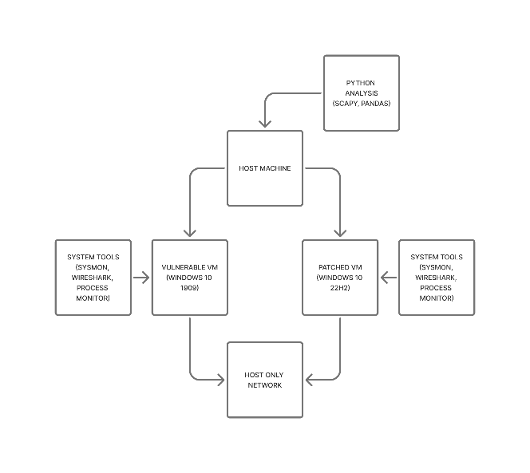
This figure illustrates the overall system design implemented in this project. The architecture is structured as a modular pipeline that supports controlled experimentation and multi-layered detection. Test traffic, including both benign and simulated malicious SMB activity, is directed towards two virtual machine environments: a vulnerable system and a patched system.
Data collection is performed concurrently across both environments, including network packet capture, system event logging, and baseline state collection. These data sources are fed into the detection framework, which operates across network, system, and behavioural layers to identify potential indicators of compromise.
The collected data is then processed using a series of automated Python scripts responsible for parsing logs, analysing network traffic, and comparing system states against established baselines. The outputs of this analysis are consolidated into structured results and visualisations, enabling both quantitative evaluation and manual investigation.
This modular design ensures reproducibility, scalability, and clear separation of concerns between data collection, detection, and analysis components, aligning with best practices in experimental cybersecurity research.

4.3 Detection Pipeline
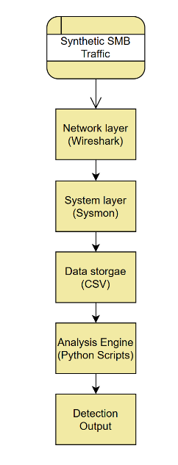
Figure 2: Multi-layer detection architecture
This figure illustrates the multi-layer detection pipeline implemented in this project. The architecture is structured across three distinct but interconnected layers: network, system, and behavioural. The network layer captures and analyses raw traffic data, including packet structures and protocol behaviour, to identify anomalies such as malformed SMB messages. This data is then correlated with system-level telemetry, including process creation and event logs, enabling the identification of host-level effects resulting from suspicious network activity. Finally, the behavioural layer applies statistical analysis to detect deviations from established baselines, allowing for the identification of subtle or previously unknown attack patterns. By integrating these layers, the system provides a defence-in-depth approach in which detection confidence increases when multiple sources indicate anomalous behaviour.

4.4 Experimental Design
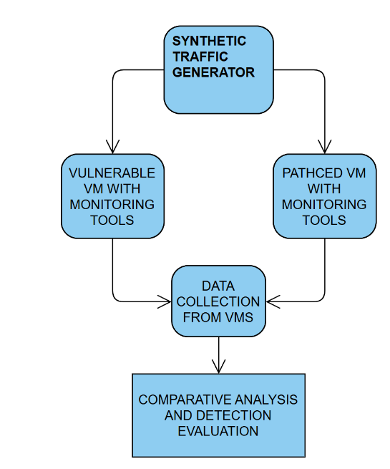
Figure 3: Experimental setup for comparative analysis
This figure illustrates the experimental setup used to evaluate the effectiveness of the proposed detection approach. Two virtual machines are configured: one vulnerable system and one fully patched system. Identical test traffic is transmitted to both environments to ensure a controlled comparison. Data from both systems is collected and analysed using the same detection framework, as well as benchmarked against established intrusion detection systems such as Snort or Suricata. This design enables direct comparison of system behaviour, detection performance, and the impact of security patches, ensuring that results are both consistent and experimentally valid.

5. Progress Summary

5.1 Virtual Machine Setup
I’ve set up two separate virtual machines so I can compare how a vulnerable system behaves versus a patched one. This dual environment approach allows direct observation of how Microsoft’s security patch prevents SMBGhost exploitation while maintaining identical system configurations for fair comparison.
Vulnerable System: Windows 10 Version 1909
I’ve installed Windows 10 Version 1909 (Build 18363.418) as my main test system. I specifically needed version 1909 because it has the unpatched SMBGhost vulnerability (CVE 2020 0796) in its SMBv3 implementation.
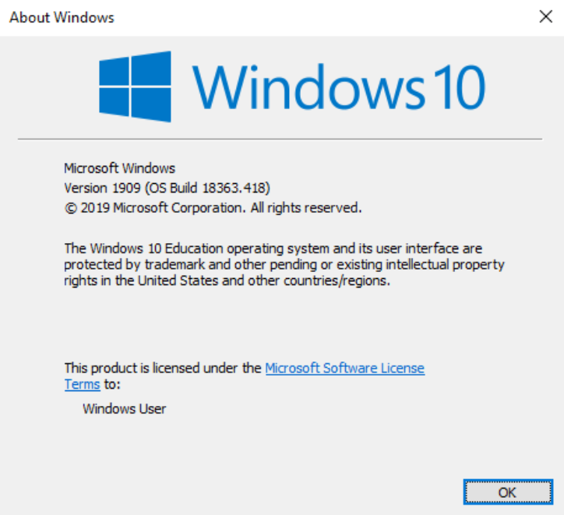
My VM Configuration: OS: Windows 10 Education Version 1909 (Build 18363.418) RAM: 2GB CPU Cores: 2 Disk Space: 60GB Platform: VMware Workstation Network: Host Only (completely isolated from everything)
What I Did to Set It Up:
- Disabled Windows Update so it doesn’t automatically patch the vulnerability
- Made sure SMBv3 is enabled and working
- Turned off Windows Defender so it doesn’t interfere with my monitoring
- Set a static IP (192.168.10.10) to make network analysis easier
- Created snapshots at each stage so I can roll back if needed
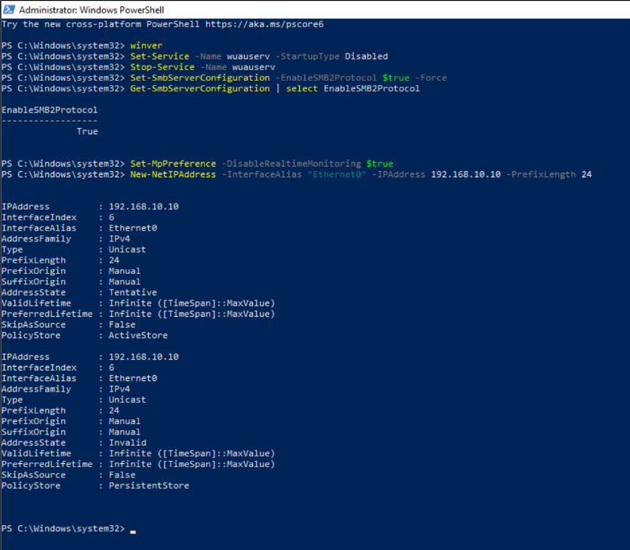
I got the Windows 10 Education ISO from the university IT department, which means I’m using legitimate software and complying with all the ethical requirements.

Patched System: Windows 10 Current
My second VM is running the current version of Windows 10 Version 22H2 (Build 19045.3803) which includes the security patch for SMBGhost. This serves as my control system.
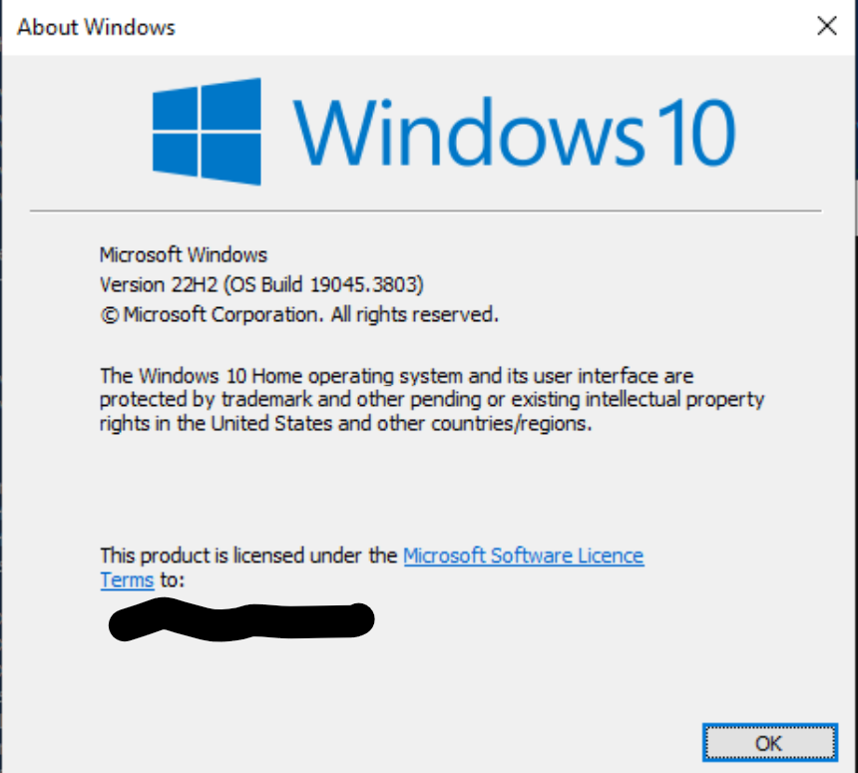
Configuration: OS: Windows 10 Version 22H2 (Build 19045.3803) RAM: 2BG CPU Cores: 2 Disk: 60GB Platform: VMware Workstation Network: Host Only (192.168.10.20)
Both systems are configured exactly the same way except for the patch status. This means any differences I see in their behaviour are due to the security update, not random environmental factors.
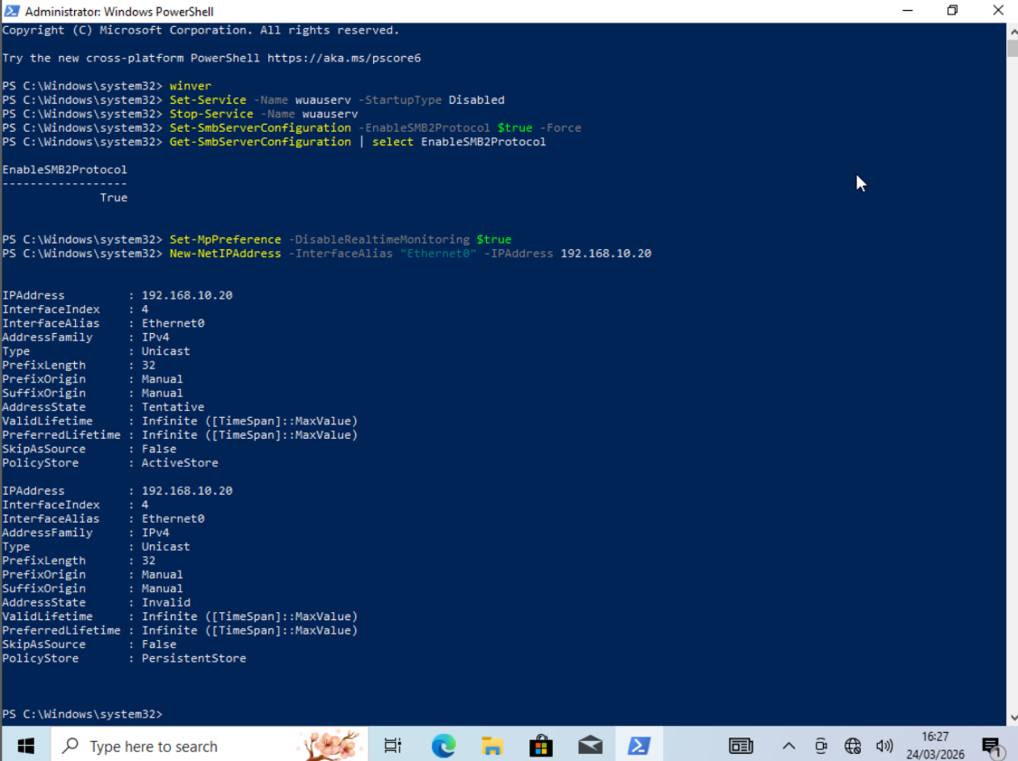

Network Isolation
This is really important. Both VMs are on a Host Only network with absolutely no connection to the internet, the university network, or anything else. This means that there is no risk of accidentally compromising real systems, no chance of anything spreading beyond my test environment and ensures full compliance with my ethics approval. I can therefore run my tests safely without worrying about consequences

5.2 Monitoring Tools
I’ve installed comprehensive monitoring on both systems so I can see what’s happening at different layers including network traffic, system activity, and application behaviour.
Sysmon (System Monitor)
Sysmon is my main tool for system level monitoring. It logs everything important that happens on the system.
Where logs go: Event Viewer → Applications and Services → Microsoft → Windows → Sysmon → Operational Status: Verified running and logging events
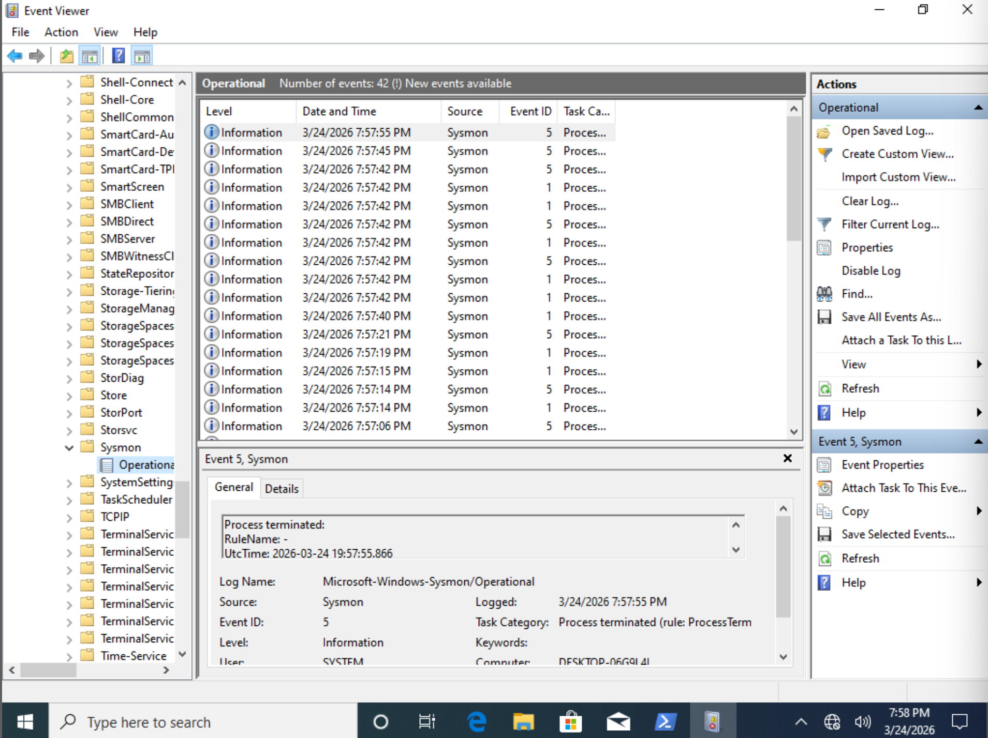
What Sysmon Captures:
- Process creation and termination
- Network connections
- File creation and changes
- Registry modifications
- Drivers and modules loading
- Process injection attempts
This gives me a complete picture of system activity and helps spot suspicious behaviour.
Wireshark
Wireshark is great for capturing and analysing network traffic, especially SMB packets.
Wireshark will let me examine the actual structure of SMB packets, spot malformed compression headers (the SMBGhost indicator), and verify my network level detection.
Python Environment
I’ve set up Python for writing analysis scripts and automating detection on the host machine. I have done this as it allows me to extract the data and analyse it on the host and saves time finding python that is compatible with the virtual machine.
I have installed Python 3.11.9 and the libraries scapy for creating and analysing network packets, pandas for data analysis and matplotlib for visualizing results.
Python is going to be my main tool for building custom detection algorithms and analysing all the data I collect.
Process Monitor
I’ve also got the full Sysinternals Suite installed. Process Monitor gives me real time visibility into file system, registry, and process activity.
Verification
I’ve confirmed everything is working. Sysmon service is running, Event Viewer shows Sysmon events being logged, Wireshark can capture traffic, Python imports all the libraries successfully, Process Monitor launches and shows activity.
Screenshots of all this are in Appendix A.

5.3 Baseline Data Collection
I am going to collect comprehensive baseline data from both systems before doing any testing. This gives me a “normal” reference point so I can spot changes that might indicate an attack.
How I Plan on Collecting Baselines
I wrote a PowerShell script (baseline_collect.ps1) that automatically gathers consistent data from both VMs. The script runs right after I finish installing the monitoring tools, capturing the system state before any attack simulation.
What I’m Collecting:
Process Information: All running processes with their PIDs, CPU usage, memory, command lines and parent child relationships, when processes started and what user they’re running as. Saved as processes.csv
Services: All Windows services and their status, Startup type, what account they run under Saved as services.csv
Network Activity: Active connections, which ports are listening, what processes are using the network. Saved as network_connections.txt, listening_ports.csv
SMB Settings: Which SMB protocol versions are enabled, signing and encryption settings, compression status (this is key for SMBGhost). Saved as smb_config.txt
Scheduled Tasks: All configured tasks, what triggers them and what they do. Saved as scheduled_tasks.csv
Installed Software: Complete list of installed programs, versions, publishers, install dates Saved as installed_software.csv
Startup Programs: Programs that run automatically at startup. Saved as startup_programs.csv
Event Logs: Recent Security events, initial Sysmon logs. Saved as: recent_security_events.csv, sysmon_baseline.csv

All baseline data is going to be timestamped and backed up. I will copy everything off the VMs to my host machine so even if something goes wrong with the VMs, I still have the baseline data.
Analysis Plan
Later I’ll compare these baselines against data collected after testing to identify any new processes that appeared, changes in network behaviour, modified services or startup items, registry and file system changes and unusual patterns in Sysmon events.
I’ll use statistical analysis to measure how much things deviate from normal behaviour.

5.4 Research Completed
SMBGhost Technical Analysis
I’ve done a deep dive into how SMBGhost works so I understand what I’m simulating.
Key Facts:
SMBGhost (CVE-2020-0796) is a critical vulnerability affecting Windows 10 versions 1903 and 1909. It exists within the SMBv3 protocol implementation, specifically in the compression functionality handled by the srv2.sys driver.
The vulnerability is classified as an integer overflow that can lead to a buffer overflow, enabling remote code execution. It has a CVSS score of 10.0, indicating maximum severity. The issue was disclosed in March 2020 and subsequently patched by Microsoft via update KB4551762.
How It Works:
SMBGhost exploits an integer overflow in how Windows handles compressed SMB messages. When the SMB server gets a specially crafted packet with a dodgy compression header, the integer overflow makes it allocate too small a buffer. Then when it tries to decompress the data, it writes beyond the buffer boundaries, corrupting memory.
This memory corruption can be used to execute arbitrary code with SYSTEM privileges because the vulnerable code runs in the kernel (srv2.sys). The scary part is you don’t need to authenticate or get a user to do anything, just send malformed packets to port 445.
Why This Matters:
SMBGhost presents a particularly severe security risk for several reasons:
1. It’s network based meaning attackers can hit you remotely
2. It’s wormable like EternalBlue/WannaCry, it could spread automatically
3. It affects enterprise environments where SMB is essential
4. Zero user interaction required
I’ve studied technical writeups from Cisco Talos, Check Point, ZecOps, and Microsoft’s own security advisory to understand the vulnerability completely.
Detection Opportunities
The analysis identified several potential indicators that can be used to detect SMBGhost-related activity across multiple layers:
Network-Level Indicators
- Malformed SMB compression headers
- Invalid or unusual compression algorithm values
- Abnormal packet sizes or structure
- Irregular SMB traffic patterns
System-Level Indicators
- Unexpected or anomalous activity on port 445
- Errors or instability associated with the srv2.sys driver
- Suspicious kernel-level memory behaviour
- Unusual process creation following SMB activity
Behavioural Indicators
- Deviations in normal SMB communication patterns
- Evidence of privilege escalation
- Emergence of persistence mechanisms after network events
These indicators inform the multi-layered detection strategy implemented in this project.
Main Findings:
The literature shows that while there’s lots of documentation about zero click attacks after they’ve happened, there’s a real lack of frameworks for studying them safely. This gap is exactly what my project addresses with the VM based simulation framework.

Appendix A: Screenshots

Screenshot 1: Both VMs in VMware

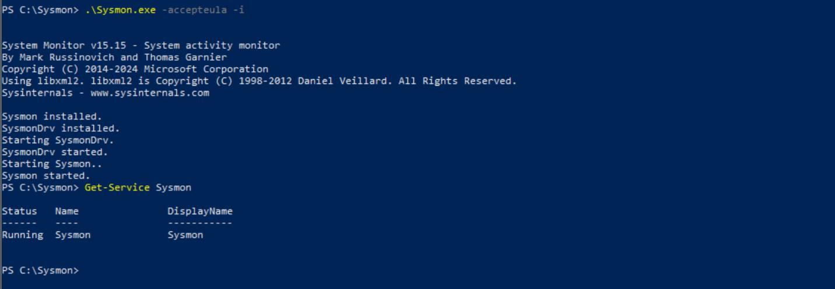
Screenshot 2: Sysmon Running
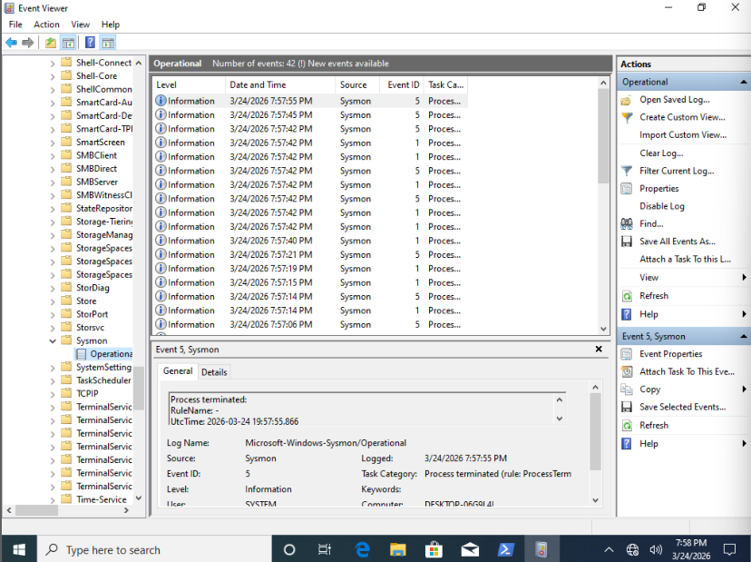
Screenshot 3: Sysmon Events

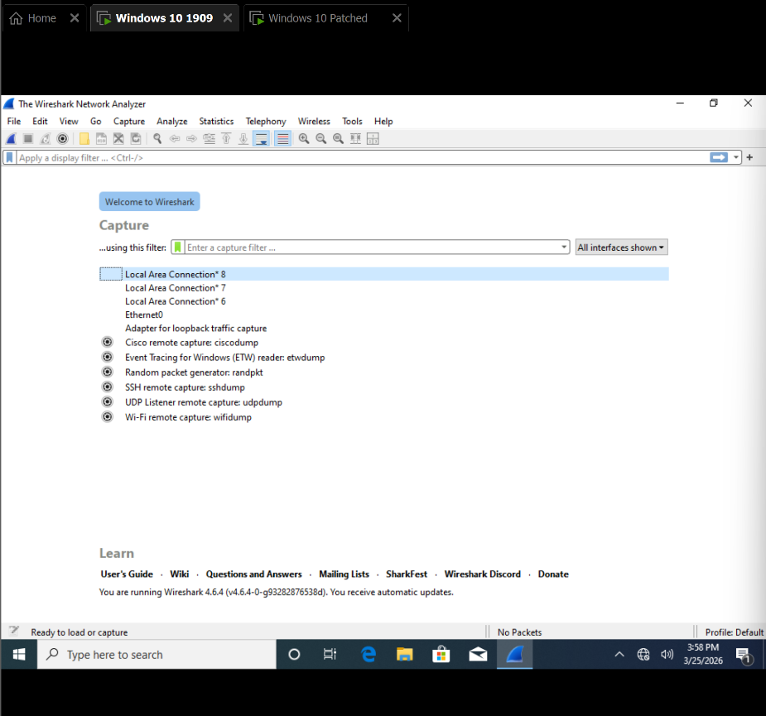
Screenshot 4: Wireshark

Screenshot 5: Python
